Implementation Log

Fire

* I want to implement some kind of random fire at the top that will damage the bird character.
* The more random, the crazier it will be, and I want it crazy!
* Triangles are quite difficult to draw with.
* Rising lava: Needs frameCount to rise.
* Using PVectors like position and velocity to determine the position of the rising lava, as well as how quickly it rises.

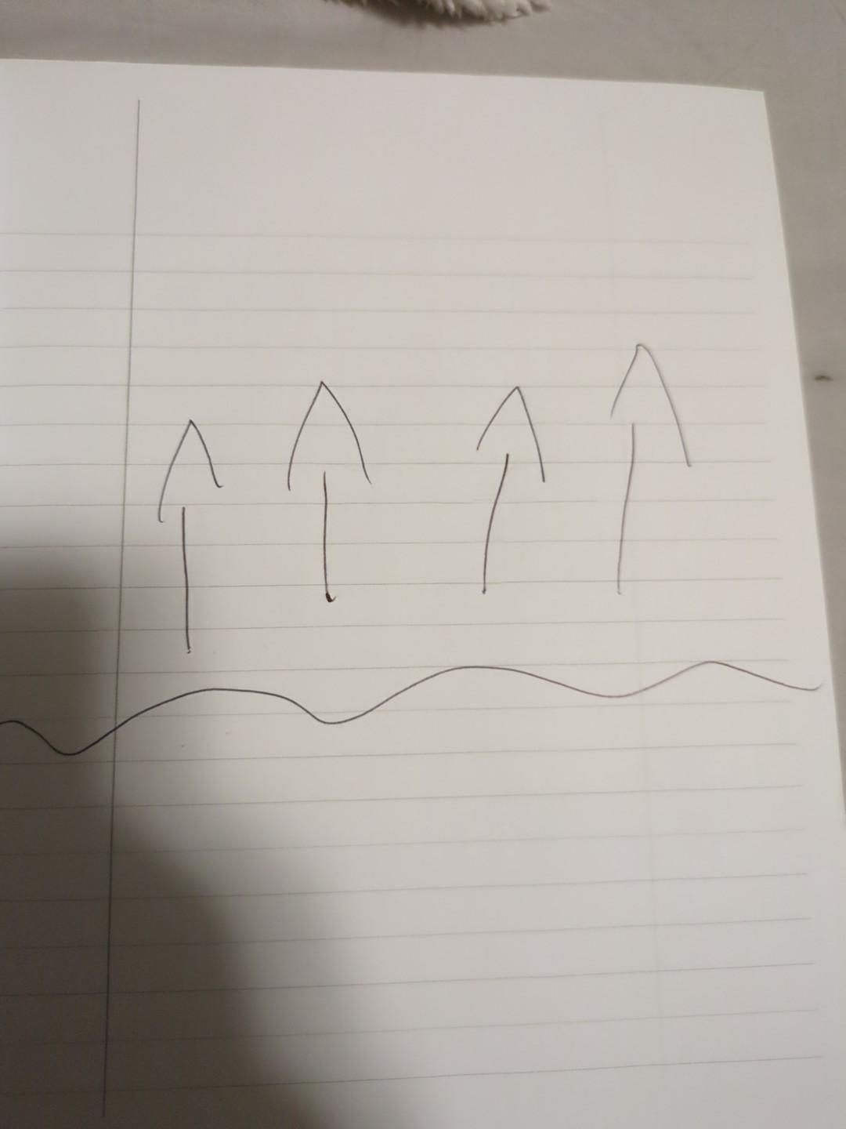

Needs to be the main

threat. Lots of testing

needed. It will be a

separate branch.

Rocks

* Need some kind of background aesthetic.
* Rocks with flowing lava would be cool!
* Random Y value positions.
* X value should be the FrameCount
* If X value exceeds the width + 300, X goes back to 0, giving the rocks a chance to reset again.
* They should stop after the game ends to prevent lag

Flow lava hole drawing.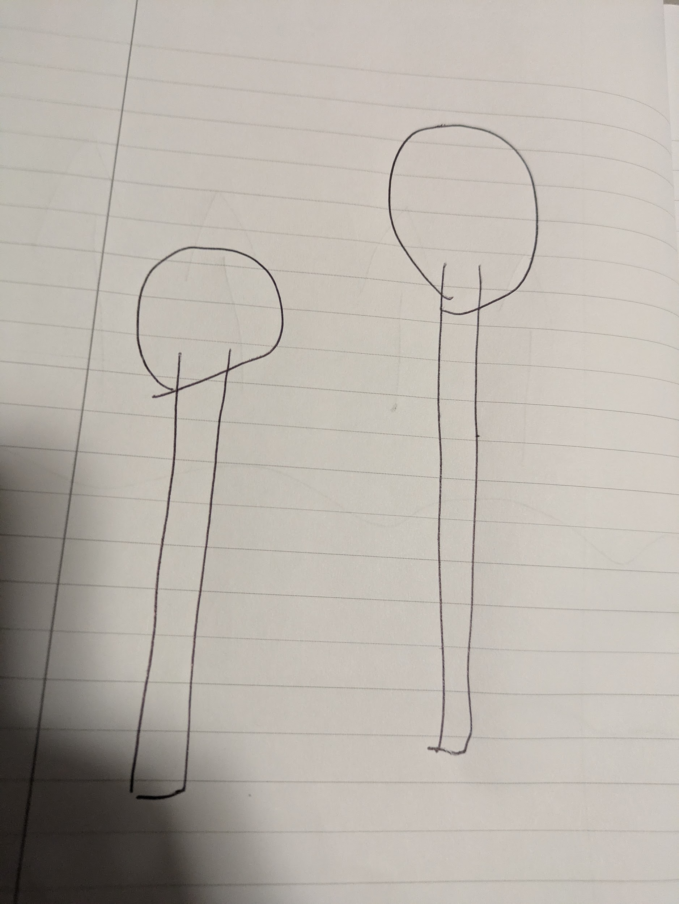

Start

* All of the code except the title screen won’t run unless the shift key is pressed.
* Title Screen: layout

Press shift to start, Press Enter to change direction, get 2300 to win.

if{keyCode==Shift} it will start

Otherwise the game will not start.